Họ và tên: Nguyễn An Phúc – 21IT639

Lab 9: Archiving and Compression

9.2 Archiving Commands

9.2.1 Step 1
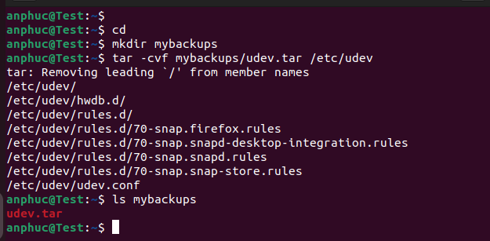

9.2.2 Step 2
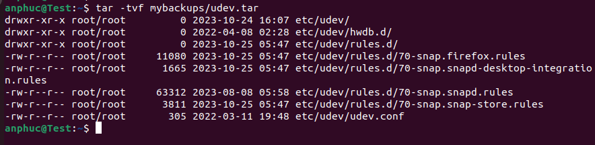

9.2.3 Step 3

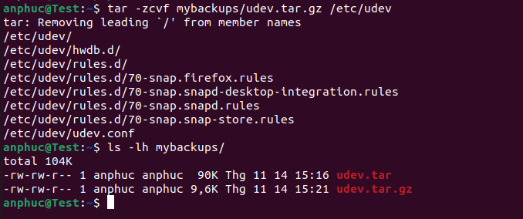

9.2.4 Step 4
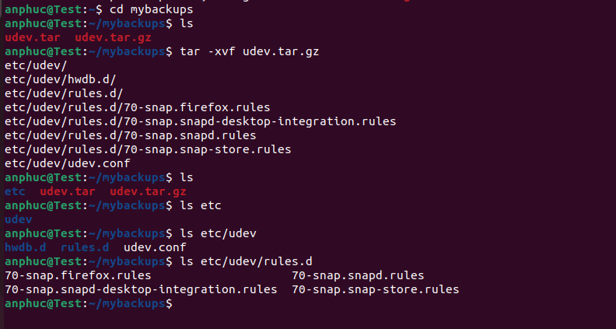

9.2.5 Step 5 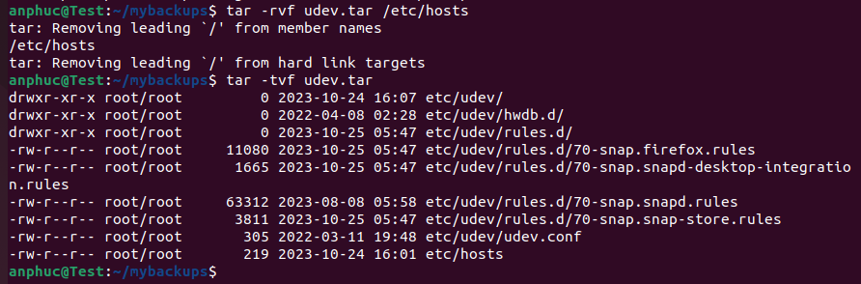
- Next

9.2.6 Step 6
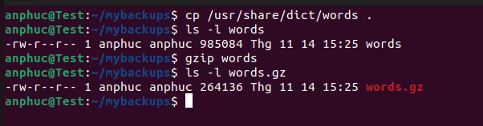

9.2.7 Step 7
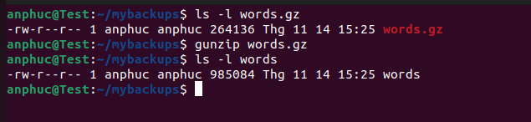

9.2.8 Step 8
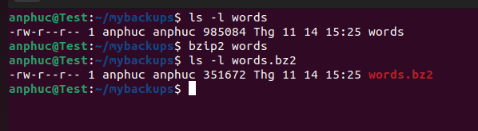

9.2.9 Step 9
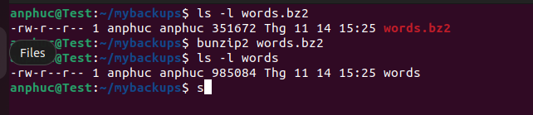

9.2.10 Step 10


9.2.11 Step 11


9.2.12 Step 12


9.2.13 Step 13
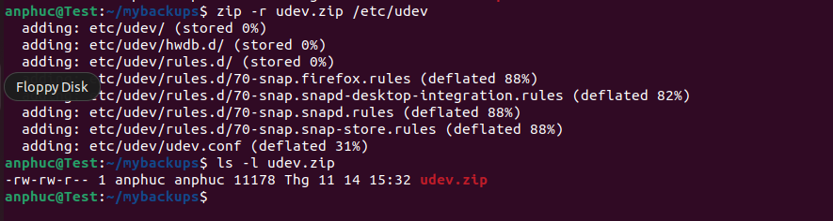

9.2.14 Step 14
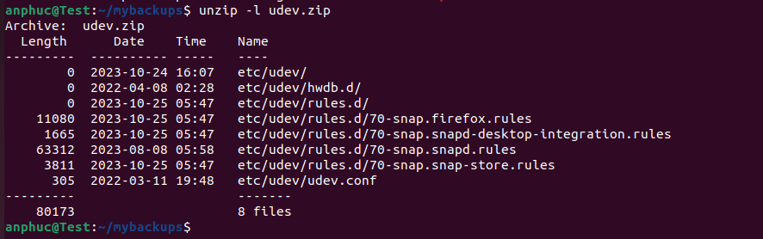

9.2.15 Step 15


